Hosting a Static Website on AWS Using S3 and Amplify

Caleb Amuah

Hi!  
Welcome to my portfolio where I have done a few exercises with the help of my mentor, Amber Israelsen. You can find her YouTube link here: <https://www.youtube.com/@TinyTechnicalTutorials>

I will be uploading more tutorials as and when, so stay tuned!

For this project, I am going to create a very simple static website on AWS. The main tools or services I will be using are Amazon S3 and AWS Amplify.

So, let’s get started!

First things first, it would be good to have this down somewhere; this is the html code for the webpage:

<html xmlns="http://www.w3.org/1999/xhtml" >

<head>

<title>My First Website</title>

</head>

<body>

<h1>My Summer Vacation - UPDATED!</h1>

<p>I'm hosted on Amazon S3!</p>

<img src="Benz.jpg">

</body>

</html>

You will need to create an HTML document out of it. Simply copy it, open a new text file and paste it into it, then save it as a ‘Hypertext Markup Language’ file.

We will begin with Amazon S3. Go over to the console and select S3 from the list of services. If it’s not there, you would have to search for it.

PS: Oh and, do pay attention to the green arrows and rounded squares I will be using in the screenshots, to make your life easier. 😉

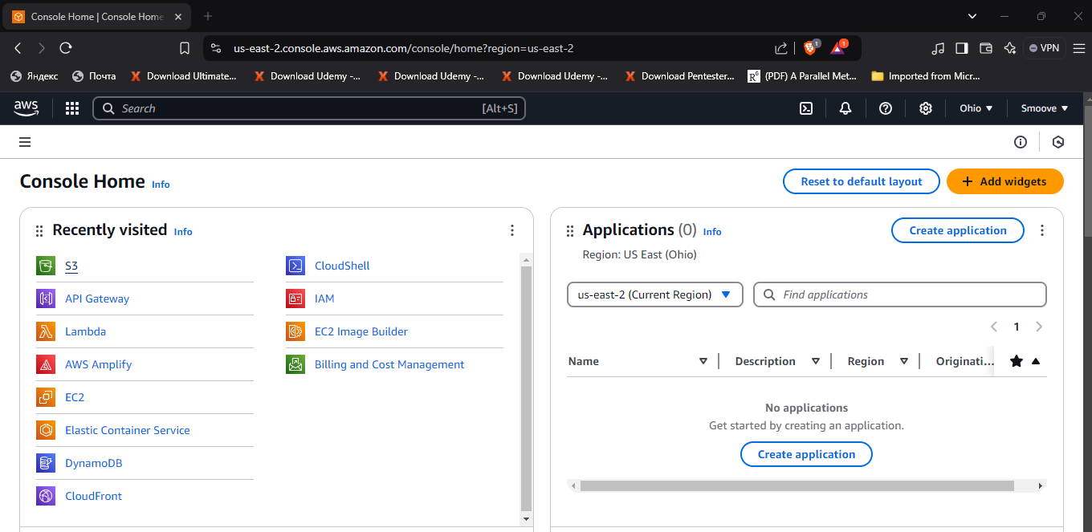

Then, click on ‘Create bucket’.

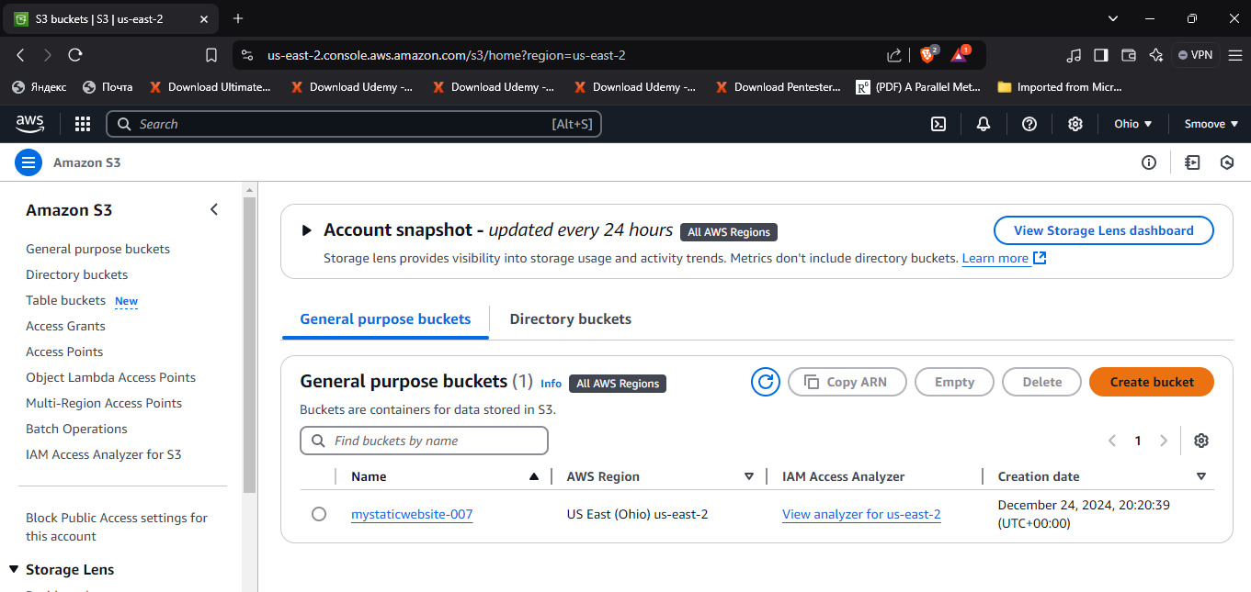

Give your bucket a name like I did mine, then scroll down all the way to the end of the page and click on ‘Create bucket’.

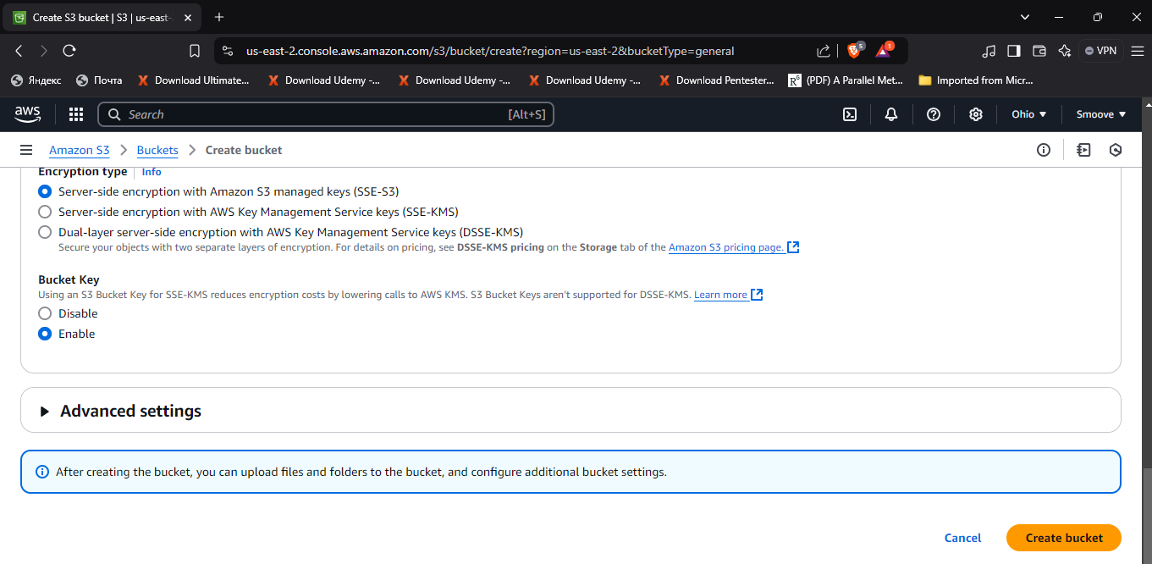

Click on ‘View details’ to go to the bucket you just created.

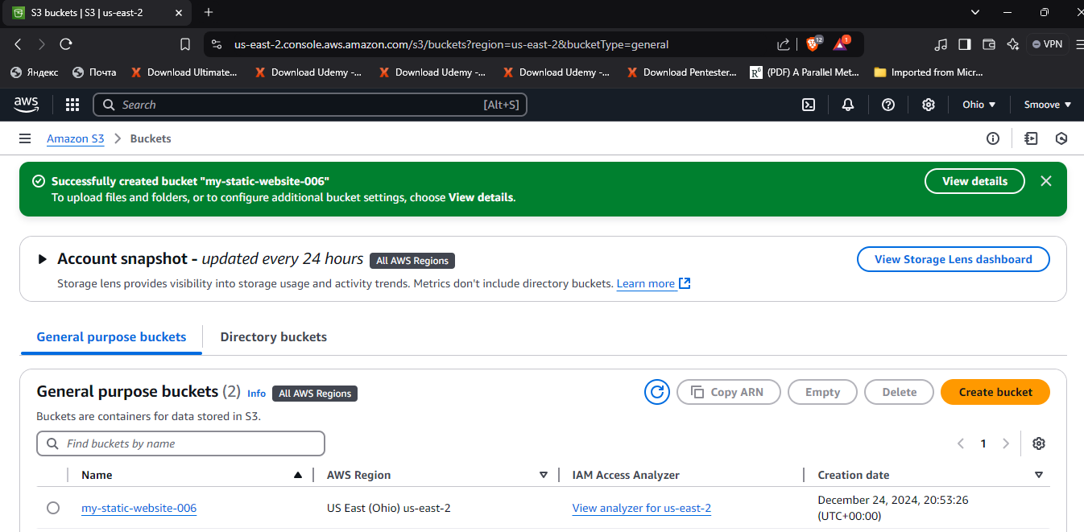

Now, you need to upload the html page and the image that you will need for your website. So here, click on ‘Upload’.

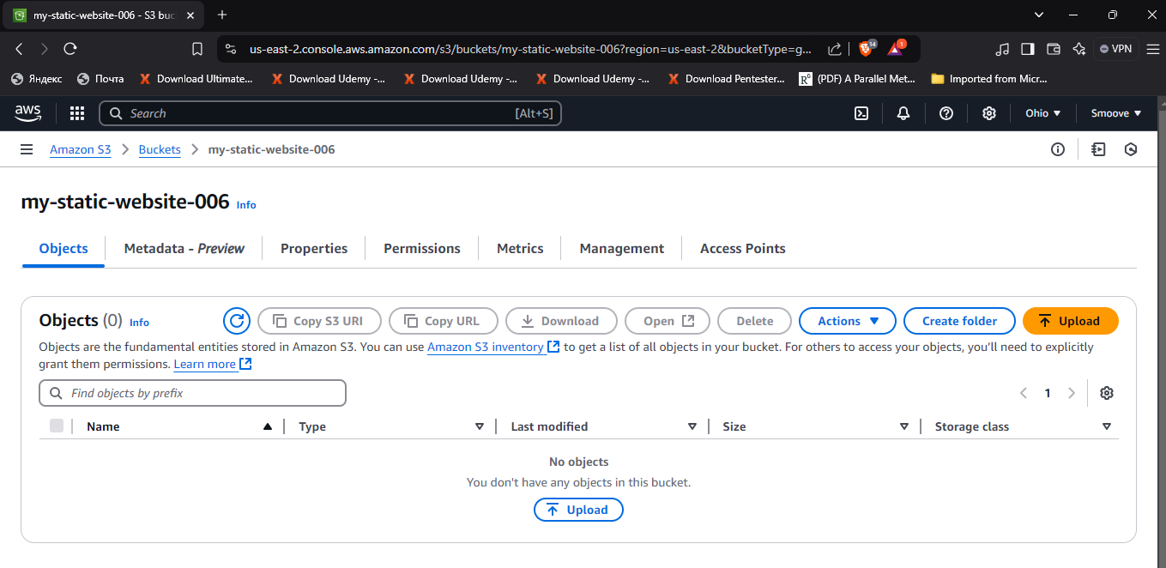

It will take you to your Windows folders, where you get to choose your uploads depending on where you have saved them. I have mine in ‘Downloads’, so I will locate and select them from there.

Click on ‘Add files’.

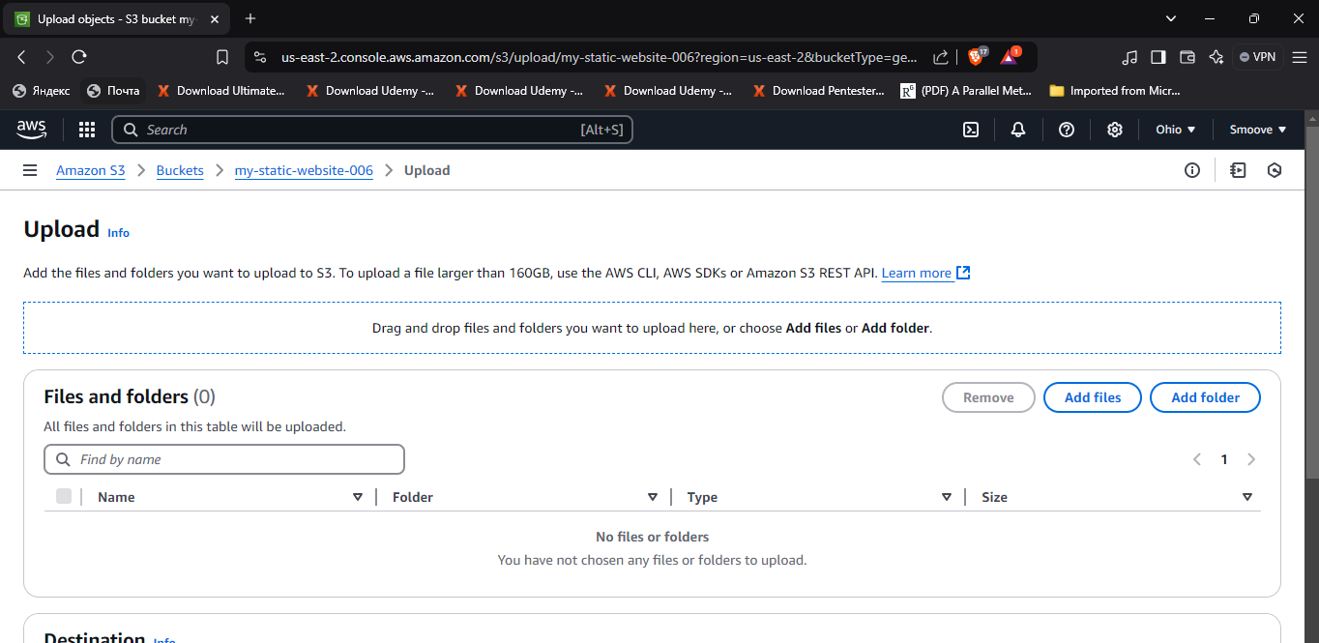

From the open folder, I selected the html file and the image I want to use (a Benz SUV because I’m a Mercedes freak😅) and clicked on ‘Open’. After, you should see them on your S3 page as shown.

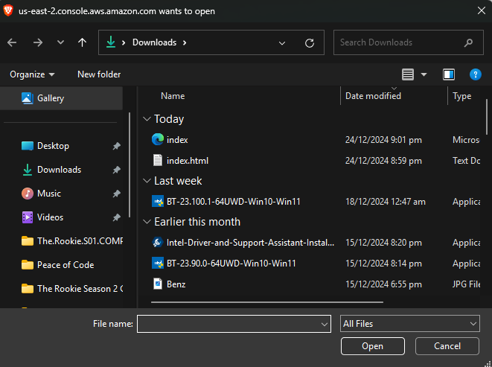

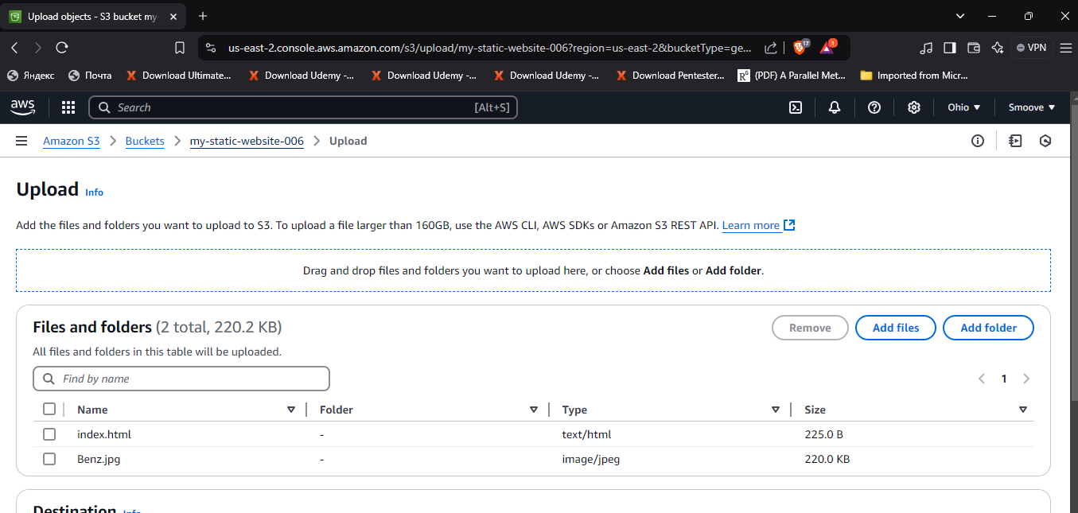

Then we can go ahead and click on ‘Upload’ at the bottom right corner.

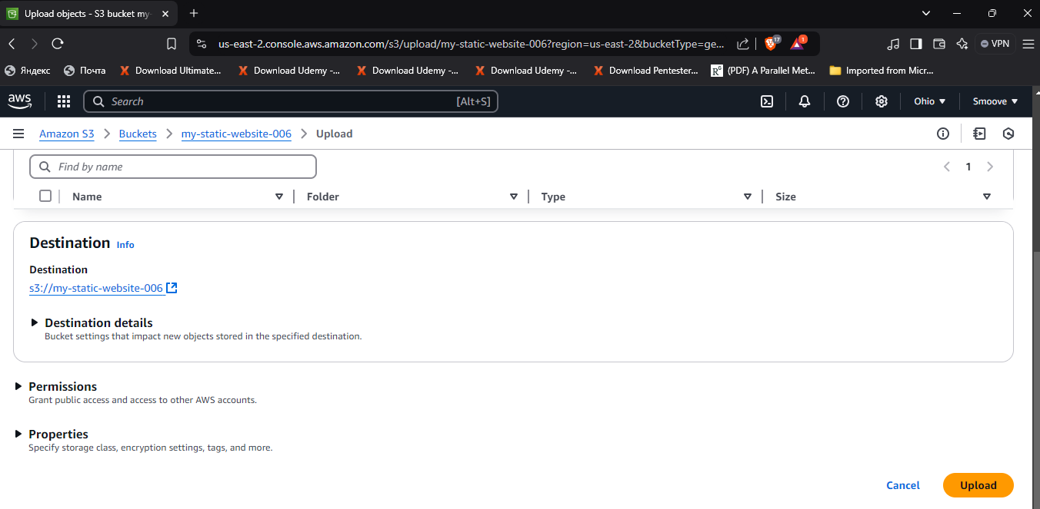

You should see a green notification showing you that your upload was successful.

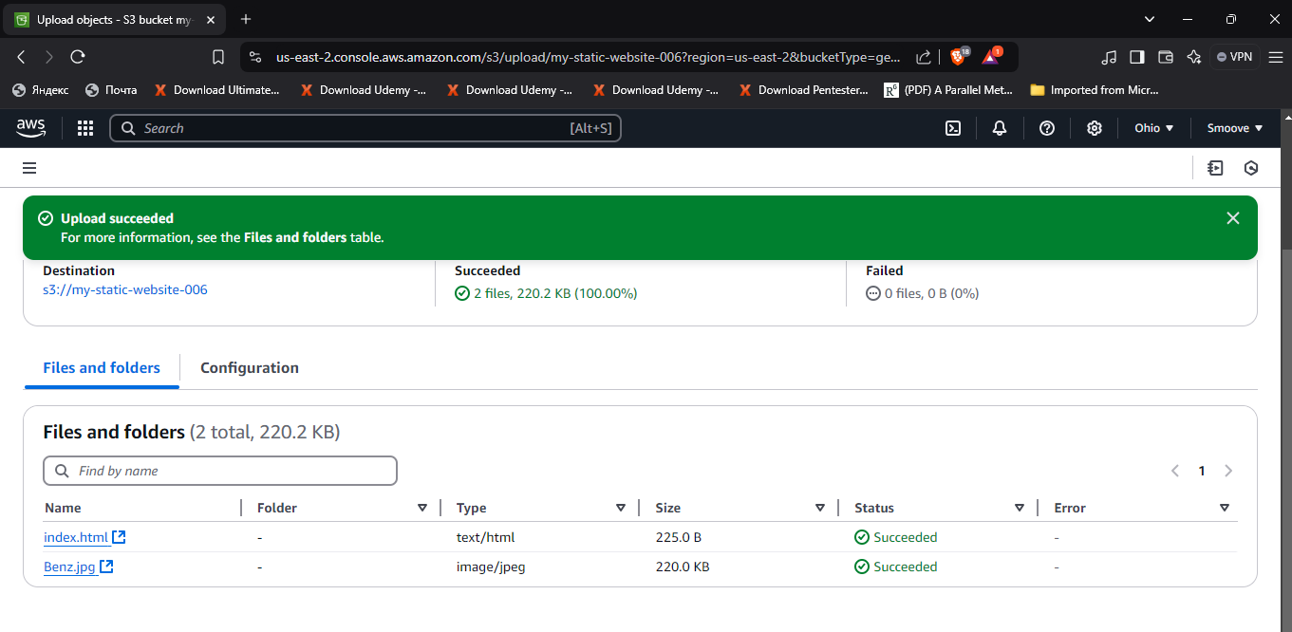

Click on ‘Close’ at the top right corner to go to the properties of your bucket.

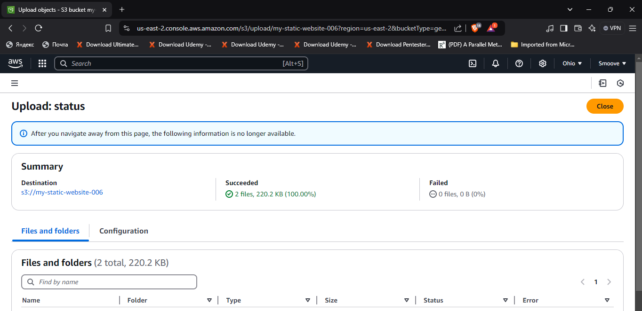

Click on ‘Properties’ and scroll all the way down to where you have the ‘Static website hosting’ option. Click on ‘Create Amplify app’.

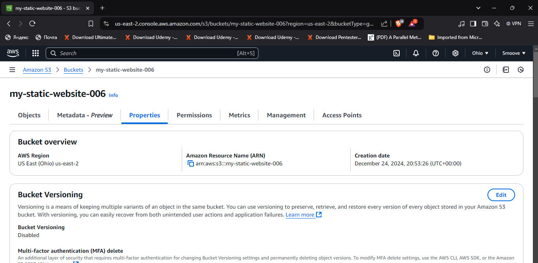

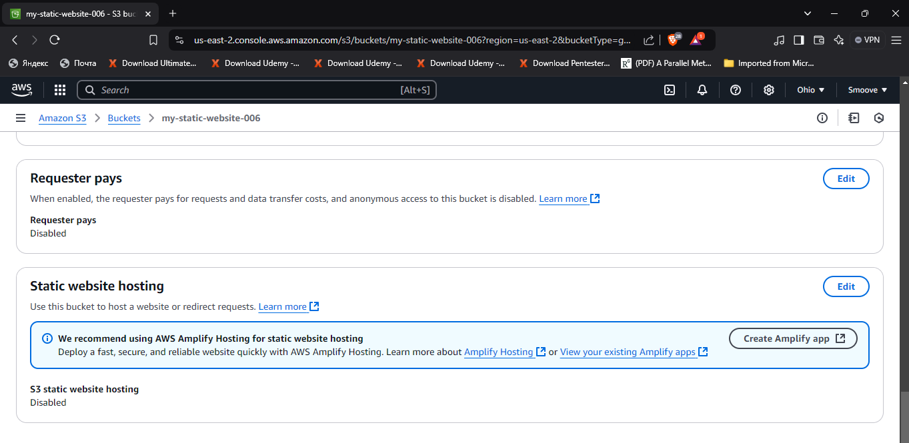

This will open a new tab for the Amplify console, where we will find that a new app has already been created for us and linked to the S3 bucket. All we would have to do would be to hit ‘Save and deploy’.

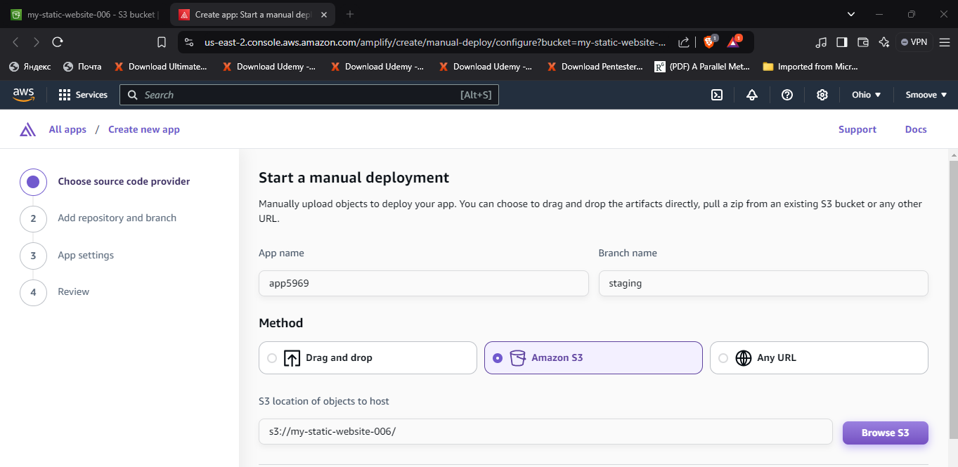

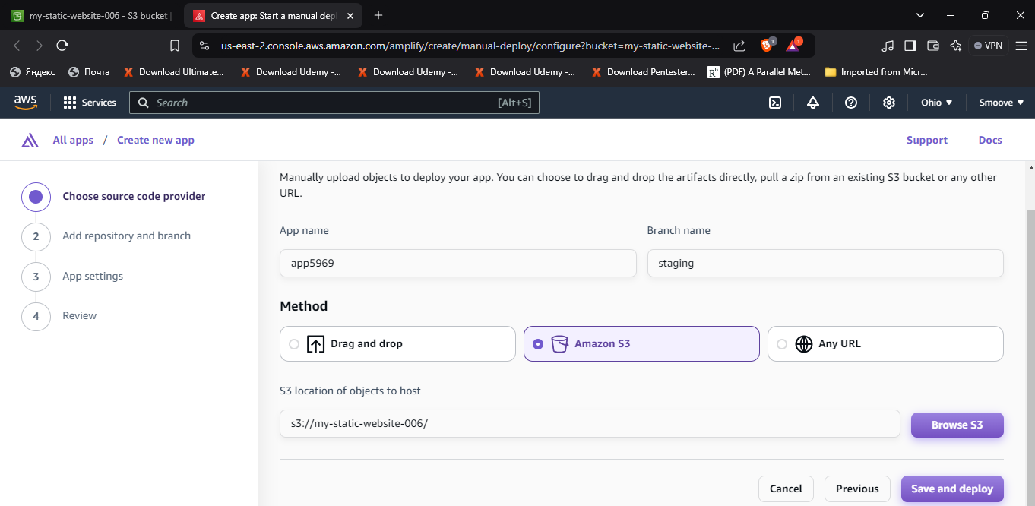

All set. Now go ahead and click on the URL under ‘Domain’.

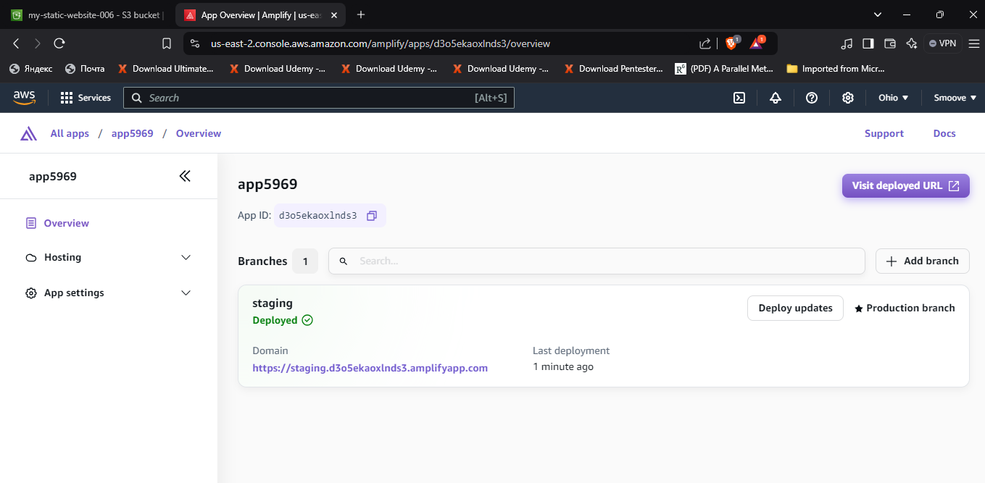

You should get something like this:

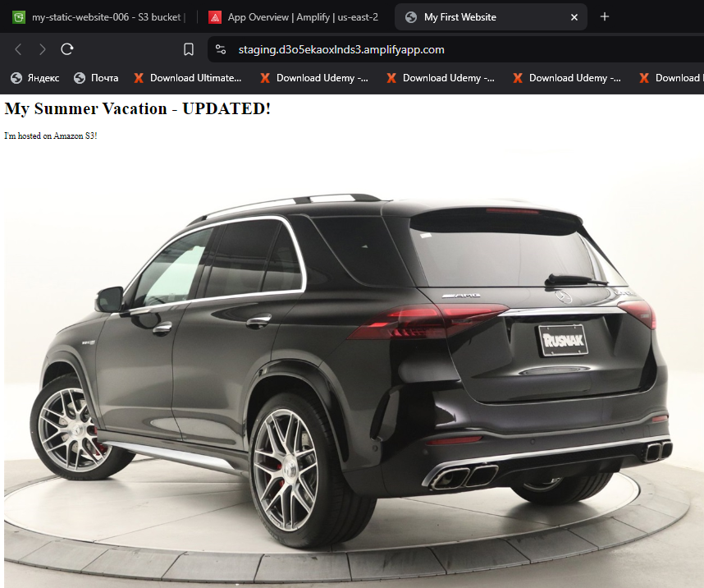

Awesome, right?

That’s pretty much it for this simple project. But before we go, always, ***ALWAYS***, remember to delete all the work you have created if it was just for practice like in this case. We don’t want any unforeseen bills next month. Very important!

So, let’s begin with the Amplify app we created. Click on ‘App settings’ on the left.

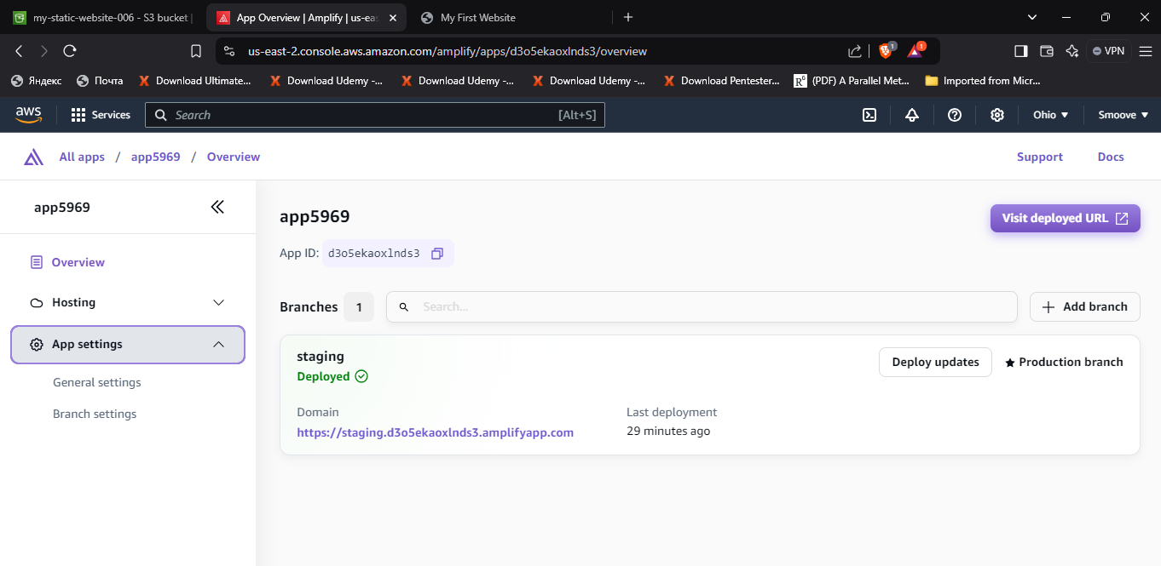

Next, go ahead and delete the app by simply clicking on ‘Delete app’ on the right.

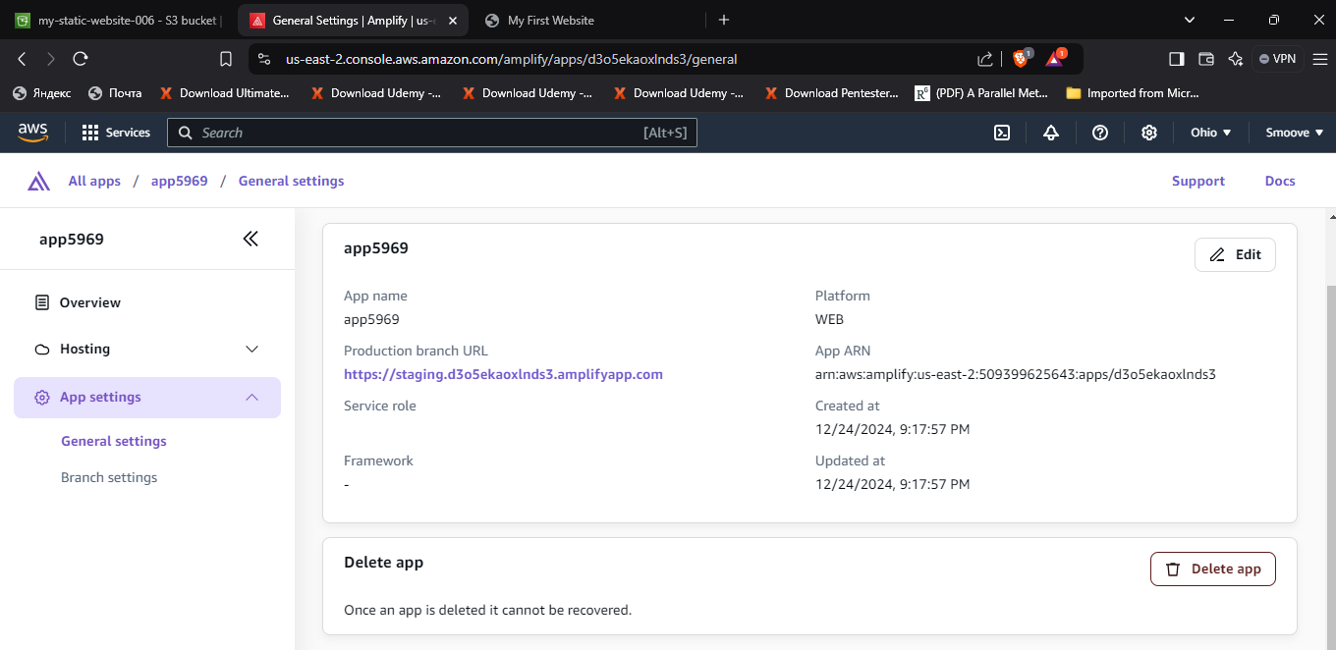

You will need to type ‘delete’ in the field indicated below as shown, to successfully get rid of it.

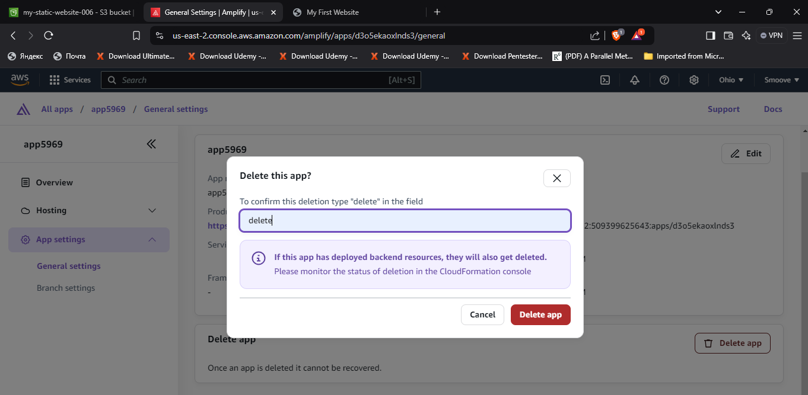

And that’s it for Amplify. Now let’s go ahead and delete the S3 bucket as well.

Select the bucket you need to delete by clicking on the bullet to the left of it as shown, and then click on ‘Delete’.

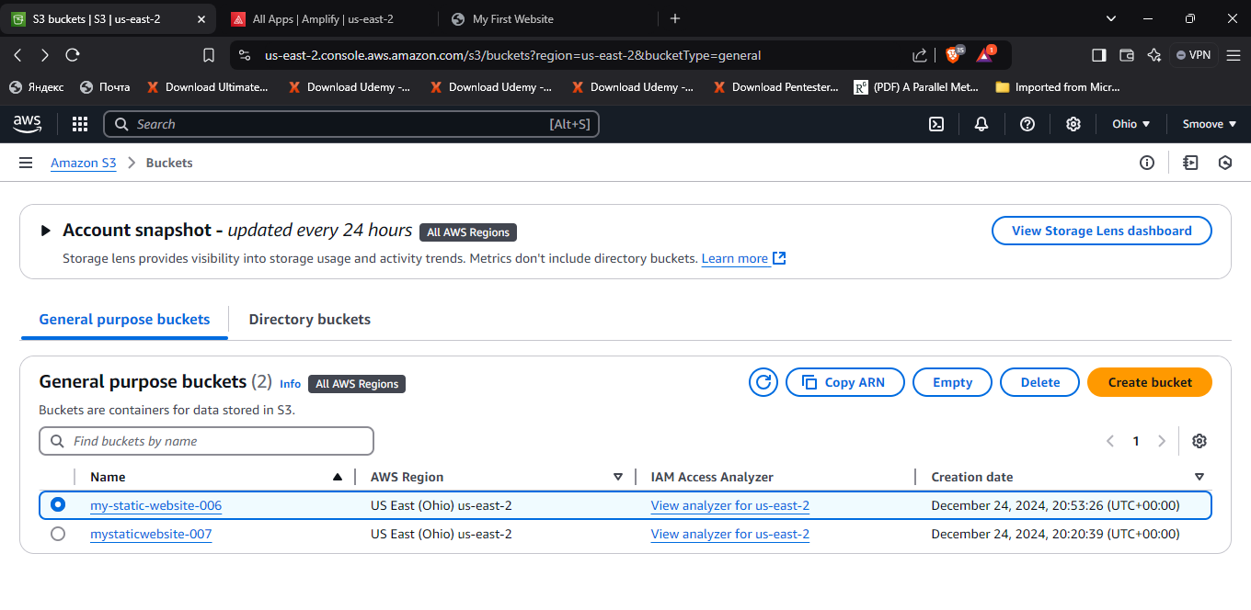

Since we already have some files saved in this bucket, we are likely going to get a notification telling us that our bucket is not empty. So, we will need to ‘clean it out’ before finally deleting it.

Click on ‘Empty bucket’ and then follow the prompts as shown.

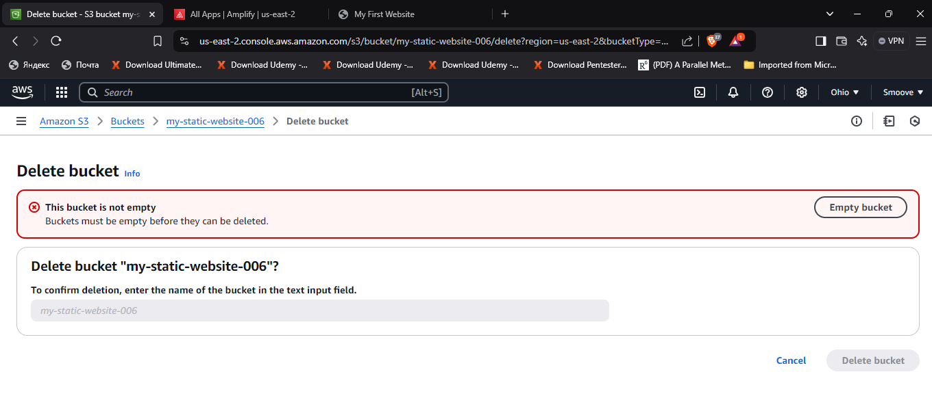

Having emptied the bucket, you may now go ahead and delete it.

